### 

### A

### PROJECT REPORT

### ON

### “ONLINE BUS TICKET RESERVATION SYSTEM”

**Submitted in partial fulfillment of requirement for the award of the degree of**

**Bachelor of Technology**

**IN**

**COMPUTER SCIENCE AND ENGINEERING**

**FROM**

**Abdul Kalam Technical University(AKTU) Uttar Pardesh , Lucknow**

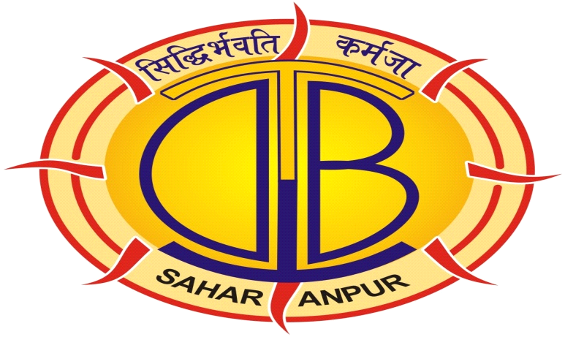

##### UNDER THE GUIDANCE OF SUBMITTED BY

**MR. RENU KUMAR NIDHI[1450210012]**

**( Asst. Professer CSE Dept.) SARITA[1450210014]**

**NEELAM GOYAL[1550210903]**

**DEPARTMENT OF COMPUTER SCIENCE**

DEV BHOOMI GROUP OF INSTITUTIONS FAULTY OF

ENGINEERING, BERI JAMA DABKI ROAD SAHARANPUR

**ACKNOWLEDGEMENTS**

We take this opportunity to express our sincere thanks and deep gratitude to all those people who incorporated their co-operation and support and have been responsible for the successful completion of our project on “ **Online** **Bus Ticket Reservation System”.**

We gratefully thanks our honorable Managing Director **Mr. Pankaj Goel** who has always supported our efforts and has been a continuous source of inspiration to us.

We gratefully acknowledge the learning environment created by our honorable Dean, **Dr. Deepak Raj Thakur** and Academic Co-ordinator , **Dr. Shiv Kumar Yadav.**

We are also indebted to the contribution of **Mr. Renu Kumar** , Asst. Professor Dept. Computer Science and Engineering , for their continuous guidance and motivation.

We would never have been able to put this work across without the guidance and support of my guide **Mr. Pramod Kumar Paigwal**, Head Of The Department, Computer Science and Engineering, who had actively been by my side while all these. His inspiring suggestions and timely guidance enabled us to perceive the various aspects of the project.

**DECLARATION**

We hereby declare that the project work entitled **“ Online Bus Ticket Reservation System”** submitted to **“Dev Bhoomi Group Of Institutions”** is the record of an original work done under the guidance of **“Mr. Renu Kumar, Asst. professor, Department Of Computer Science and Engineering, DBGI, Saharanpur”** and this project work is submitted in partial fulfillment of the requirements for the award of **"B.Tech, Final Year (regular)" in “Computer Science and Engineering”.**

The results embodied in this project have not been submitted to any other University or Institute for the award of any degree/diploma.

We have conformed to the norms and guidelines given in the *ethical code of conduct* of the institute.

Nidhi (1450210012)

Sarita (1450210014)

Neelam Goyal (1550210903)

**CERTIFICATE**

This is to certify that the project entitled, **“ Online Bus Ticket Reservation System”** submitted by **"NIDHI ,SARITA ,NEELAM GOYAL"** in partial fulfillment of the requirements for the award of **"B.Tech, Final Year (regular)"** in **"Computer Science and Engineering "** at the **"Dev Bhoomi Group Of Institution, Saharanpur"** is an authentic work carried out by them under my supervision and guidance.

To the best of my knowledge, the matter embodied in the project has not been submitted to any other University / Institute for the award of any Degree or Diploma.

**Date:**

Project Guide:

MR. RENU KUMAR

**MR. PRAMOD KUMAR PAIGWAL**

**HEAD OF THE DEPARTMENT**

**DEPARTMENT OF CSE**

**DBGI, SAHARANPUR, 247001**

**ABSTRACT**

Our Bus Travel Facility is provides Online Bus ticket Reservation System. In our System we can provides different types of buses categories like Express, Volvo, AC or Non AC etc.

In our system we can manage all types of Passenger data & bus data. All details that is related to Traveling like fare details ,Seat availability, details of Booking, bus details, seating arrangements, inquiry etc.   
  
 In our system we can provide the features to the passenger like the passenger could choose the available seats own itself, that is not provided   
by any other Agency. Our system also provide the facility like the Bus Boarding and the admin has facility to send Email & SMS.

**TABLE OF CONTENTS**

# 

**CHAPTER 1: INTRODUCTION 1**

1.1 Introduction 1

1.2 Project objective 2

1.3 Existing system 2

1.4 Proposed system 3

1.5 Modules 4

1.5.1 login 4

1.5.2 Reservation system 4

1.5.3 Book the ticket 4

1.5.4 Cancel book ticket 4

1.5.5 Update bus information 4

1.6 Advantage 5

**CHAPTER 2: REQUIREMENT GATHERING 6**

2.1 User interface 6

2.2 Hardware requirement 6

2.3 Software requirement 6

2.4 Non functional requirement 7

2.4.1 Usability 7

2.4.2 Security 7

2.4.3 Performance 7

2.4.4 Availability 7

2.4.5 Error handling 8

2.4.6 Ease of use 8

2.5 Security requirement 8

2.6 Functional requirement 8

**CHAPTER 3: FEASIBILITY STUDY 10**

3.1 Feasibility study10

3.1.1 Technical Feasibility 10

3.1.2 Economical Feasibility 11

3.1.3 Operational Feasibility 11

**CHAPTER 4: SYSTEM ANALASIS 12**

4.1 Use case diagram for admin 12 4.2 Use case diagram for customer 13

4.3 Activity diagram for admin 14 4.4 Activity diagram for customer 15

4.5 Use case diagram 16

4.6 E-R diagram 17

4.7 State diagram 18

4.8 Data flow diagram (DFD) 19

4.9 Class diagram 20

4.10 Sequence diagram for admin 21

4.11 Sequence diagram for customer 22

**CHAPTER 5: SYSTEM DESIGN 23**

5.1 Home page 23

5.2 Gallery 24

5.3 Ticket booking 25

5.4 Registration 26 5.5 Ticket reserve detail 27

5.6 Admin login 28

5.7 Customer detail 29

5.8 Bus detail 30

5.9 Add bus details 31

5.10 Seat detail 32 5.11 Routes detail 33

5.12Router map 34

5.13 Contacts 35

**CHAPTER 6: CODING 36**

6.1 Coding 36

**CHAPTER 7: TESTING 42**

7.1 Testing 42

7.1.1 Acceptance testing 42

7.1.2 System testing 42

7.1.3 Integration testing 43

7.1.3.1 Bottom-up integration testing 44

7.1.4.2 Top-down integration testing 44

7.1.4 Unit testing 44

7.1.5 Validation Testing 45

**CHAPTER 8 : IMPLEMENTATION 46**

**CHAPTER 9 : FUTURE ENHANCEMENT 48**

**CHAPTER 10: CONCLUSION 49**

**CHAPTER 11: REFERENCE 50**

**LIST OF FIGURE**

S.NO. Figure no. Figure Title Page no.

1. Figure 3.1.1 Use case diagram (admin) 12

2. Figure 3.1.2 Use case diagram (customer) 13

3. Figure 3.1.3 Activity diagram (admin) 14

4. Figure 3.1.4 Activity diagram (customer) 15

5. Figure 3.1.5 Use case diagram 16

6. Figure 3.1.6 E-R diagram 17

7. Figure 3.1.7 State diagram 18

8. Figure 3.1.8 DFD 19

9. Figure 3.1.9 Class diagram 20

10. Figure 3.1.10 Sequence diagram (admin) 21

11. Figure 3.1.11 Sequence diagram (customer) 22